

Connected Learning Platform (CLP)

Protractor setup in Linux Environment

**Protractor Setup in Linux Environment**

**(Run in Headless Browser)**

**Required Software’s**

1. Java
2. JDK
3. Node js v6.11.3
4. npm 3.10.10
5. Protractor 5.1.2
6. Mozilla Browser
7. Chrome Browser

**Installing Protractor**

npm install -g protractor

Once installed check the version protractor –version

**Installing Firefox Browser**

Check the link for installing the Firefox browser

<https://tecadmin.net/install-firefox-on-linux/>

**Installing Chrome Browser**

Check the link for installing the chrome browser in Linux environment

<https://tecadmin.net/install-google-chrome-in-ubuntu/>

**Xvfb settings**

This helps to set the display for headless browser to run in Linux environment

Kill the previous setting

ps -aux | grep Xvfb

kill -9 PID

sudo rm /tmp/.X11-unix/X99

Execute the below syntax to set the XVFB

export DISPLAY=:99

Xvfb :99 -ac -screen 0 1280x1024x24 &

C:\Users\t.ayyasamy\AppData\Local\Microsoft\Windows\INetCache\Content.Word\Xvfb setting.png

*Once installed all the above softwares and settings, start the server using*

sudo npm install webdriver-manager -g

*(After installing the webdriver-manager, it will show the version*

*webdriver-manager: using global installed version 12.0.6)*

sudo webdriver-manager update

sudo webdriver-manager start

*If Protractor installed properly, then we need to run the Protractor using examples files which will have it in the Protractor package itself*

*It will be available in the path*

/usr/lib/node_modules/protractor/example

Inside example, we need to check the config.js



*Open the config.js file and update the below script*

|  |
| --- |
| // An example configuration file.  exports.config = {  // directConnect: true,  seleniumAddress: 'http://localhost:4444/wd/hub',  // Capabilities to be passed to the webdriver instance.  capabilities: {  'browserName': 'firefox'  },  // Framework to use. Jasmine is recommended.  framework: 'jasmine',  // Spec patterns are relative to the current working directory when  // protractor is called.  specs: ['example_spec.js'],  // Options to be passed to Jasmine.  jasmineNodeOpts: {  defaultTimeoutInterval: 30000  }  }; |

*Goto the below directory*

/usr/lib/node_modules/protractor/example

*Run the command*

[centos@ip-172-16-142-120 example]$ **protractor conf.js**

*After executing this command, the example script will run and it will show the result as*

*If the browser is Chrome*

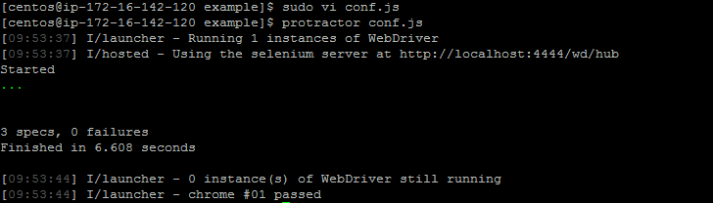

*If the browser is Firefox*

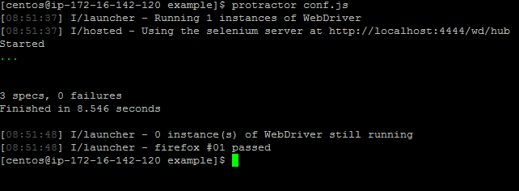

*Now, the Protractor installed properly and able to run in Linux environment using Headless browser*